JAAFER (GB)
PA 2003 Grey Colt
By Amer out of Madjela (Manganate)
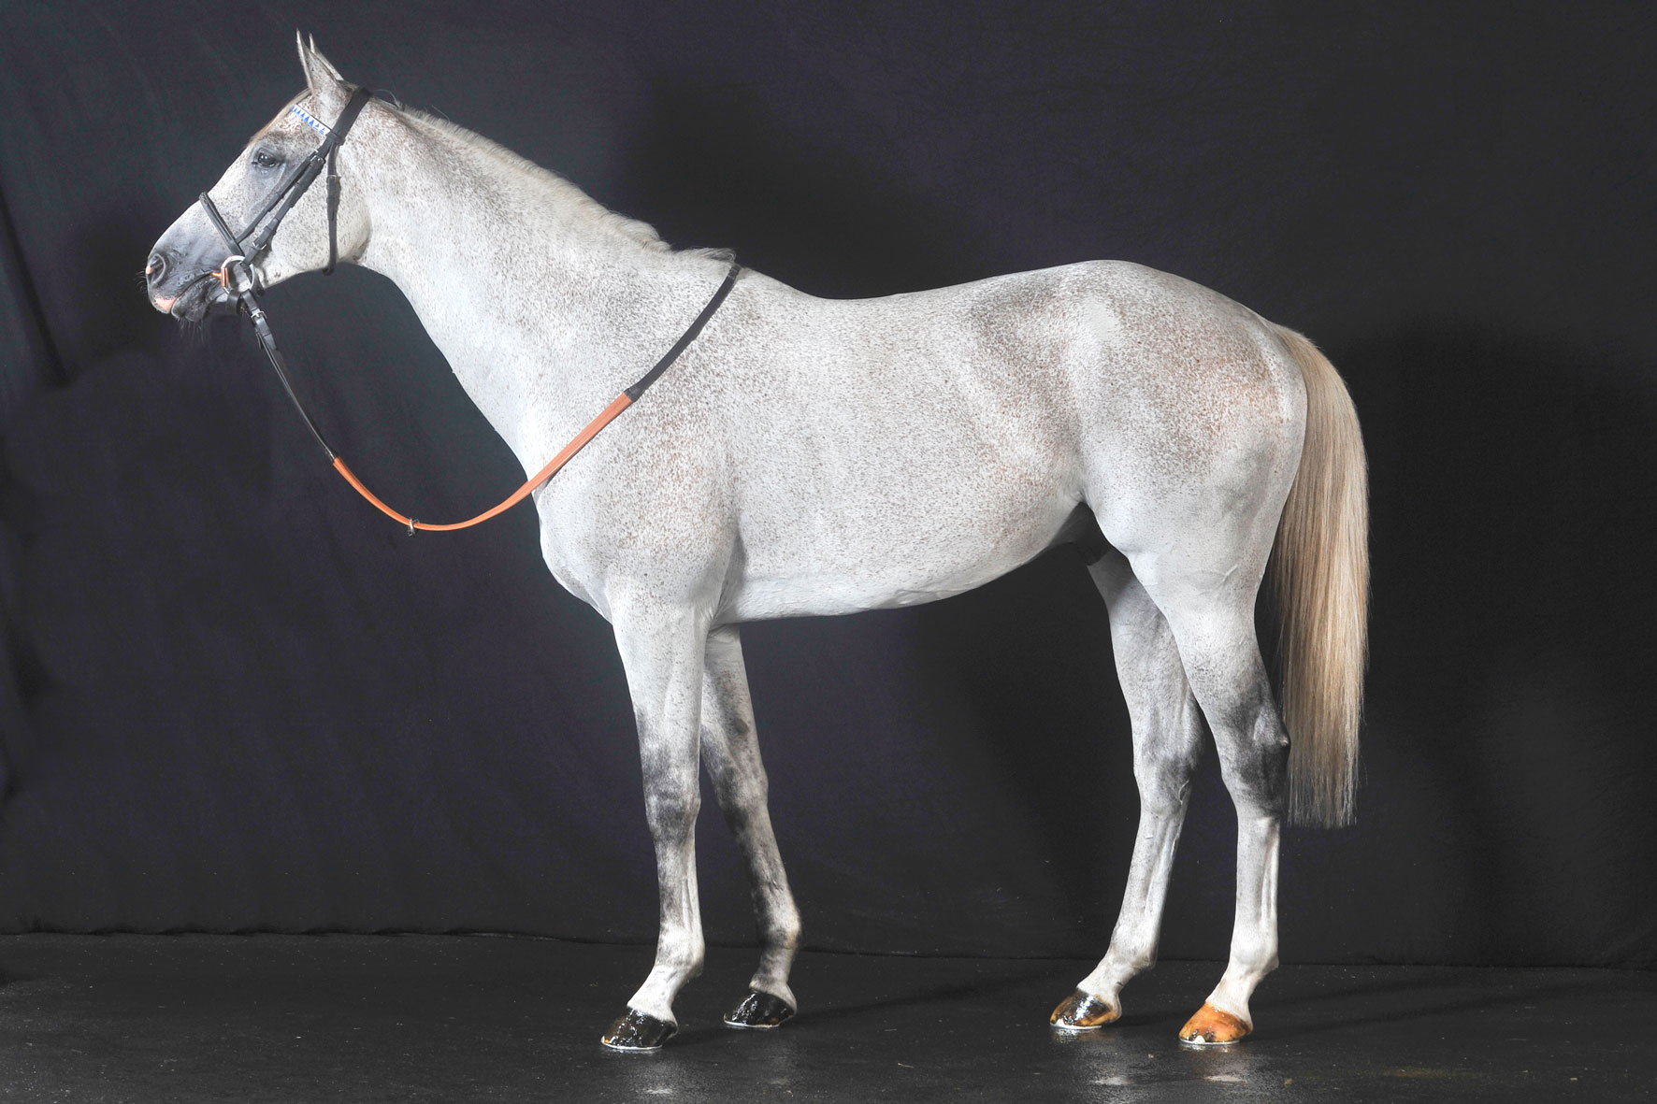

Race Record:
From 48 career starts –He has 15 WINS and 26 Places.
TOTAL PRIZE MONEY of938,057EUR
15WINS – Including:

H.H The Emir’s Sword (Group 1 PA) 2400m (Doha) - 2011
Kahayla Classic (Group 1 PA) 2000m (Meydan) - 2010
The Shadwell Dubai International Stakes (Group 1 PA) 2000m (Newbury) - 2010
Qatar National Day Trophy (Group 1 PA) 2000m (Doha) - 2008
The Qatar International Stakes (Group 2 PA) 2400m (Lingfield Park) - 2008
The Qatar International Derby (Group 2 PA) 2000m (Doha) - 2007
H.H. The Heir Apparent Trophy PA 2000m (Doha) - 2009
The Al Shahania Stud International Stakes 2000m (Newbury) - 2012
Sheikh Suhaim Cup 1850m (Doha) - 2009
P/A Derby Trial 1850m (Doha) - 2007
11 Seconds – Qatar International Trophy (Group 1 PA) 1600m (Doha) - 2009
The Shadwell Dubai International Stakes (Group 1 PA) 2000m (Newbury) - 2008
Qatar National Day Trophy (Group 1 PA) 2000m (Doha) - 2010
Qatar Cup (Prix Dragon) (Group 2 PA) 2000m (Longchamp) - 2011
The Abu Dhabi Harwood International Arabian St. (Group 2 PA) 1600m (Newmarket) - 2011
The Abu Dhabi International Stakes (Group 2 PA) 1600m (Newmarket) - 2010
The Georgina Ward Arabian Racing Stakes (Group 2 PA) 2000m (Newbury) - 2008
The Sheikh Abdullah Bin Khalifa Al ThaniInt(Group 3 PA) 1850m (Doha)- 2012
H.H. The Heir Apparent Trophy PA 2000m (Doha) - 2008
Qatar Cup PA Germany 1800m (Hamburg) - 2008
GCC Champion Breeders Cup1850m (Doha) - 2009
7 Thirds – Including:
Qatar Arabian World Cup (Group 1 PA) 2000m (Longchamp) - 2011
H.H. The Emir’s Sword (Group 1 PA) 2400m (Doha)- 2012
Shadwell Dubai International Stakes (Group 1 PA) 2000m (Newbury) - 2011
Qatar National Day Trophy (Group 1 PA) 2000m (Doha) - 2009
Qatar International Trophy (Group 1 PA) 1850m (Doha) - 2008
H.H. The Heir Apparent Trophy PA 2000m (Doha) - 2010
7 Fourths – Including:
Qatar Arabian World Cup (Group 1 PA) 2000m (Longchamp) -2010
H.H. The Emir’s Sword (Group 1 PA) 2400m (Doha) - 2008 & 2009
Qatar International Trophy (Group 1 PA) 1850m (Doha) - 2010
H.H. The Heir Apparent Trophy PA (Group 1 PA)2000m (Doha)– 2012
1 Fifth - Prix Dragon (Group 2 PA)2000m(Longchamp) - 2009

JAAFER  M.Gr. 2003 | Amer | Wafi | Shabab
 |  |  | Sarhah
 |  | Bushra | Lahoom
 |  |  | Rahifa
 | Madjela | Manganate | Saint Laurent
 |  |  | Mandragore
 |  | Mandore | Grabiec
 |  |  | Mandarine III

1st Dam:
Madjela (f. Manganate), Full sister to DORMANE, DJAMEL, DJENDEL, MADJEL, MARGAU,MANGADORE. Dam of:
ALMAS (m. Tidjani) 7 WINS, H.H. The Emirs Sword (Doha) (Gr.1 PA), H.H. Heir Apparent Sword (Doha) (Gr.1 PA), H.H. The Prime Minister’s Trophy (Doha), Qatar Derby Cup (Doha).
JAAFER (m. Amer)See Above.
Ajeeb (m. Al Sakbe) placed in Qatar.
Mansourah(f. Burning Sand)1 WIN in Qatar, 2ndQatar Oaks (Gr.2 PA) 2000m, Oaks Trial (Gr.3 PA) 1850m.

Jamra (f. Amer) Placed in Qatar.

Al Nefor (f. Amer)in training.

2nd Dam:
Mandore(f. Grabiec), 2 WINS at 4 years, 4 places at 3 and 4 years, 2ndPrix Spécial (Tarbes). Dam of:
DORMANE, (m. Manganate), 6 WINS at 3 and 4 years, Dubai St. (Kempton), Coupe du Cheval Arabe (Evry).
Stallion.
DJAMEL (m. Manganate) 6 WINS at 3 and 4 years, Zaabeel St. (Kempton), Prix Dragon (La Teste), Ourour, Dénouste, Saint-Laurent. Stallion.
MARGAU, (f. Manganate), 4 WINS at 4 and 5 years, Prix France Arabe (Toulouse), Dragon (La Teste), 14 places. Dam of:
SANTHAL, (m.), 6 WINS, Al Maktoum Challenge R3 (Gr.1 PA), 2nd Dubai Int’l St.(Gr.1 PA), AlMaktoumChallenge R1 (Gr.1 PA).
MASSAMARIE, (f.), 4 WINS, Derby des PSA (Chantilly). Dam of:
MARED AL SAHRA, (m.), 6 WINS at 4 and 8 years, Emir’s Sword (Doha) (Gr.1 PA), 3rd Int’l Trophy (Doha) (Gr.1 PA), and 458 006 €.
MU’AZZAZ, (m. Amer), 7WINS,The Shadwell Dubai International Stakes (Gr.1 PA) (Newbury), The Arabian Horse Organization Hawthorn Hill International Stakes (Gr.2 PA) (Newbury),2ndH.H The Heir Apparent Trophy (Gr.1 PA),Abu Dhabi International Stakes (Gr.2 PA),Yousef Al Romaihi Cup (Gr.3 PA)3rd UAE Presidents Cup (Gr.1 PA).
Marja, (f.), 5 WINS, 2nd President of The UAE (Epsom). Dam of:
MALEEHAH, (f.), 16 WINS, Coupe d’Europe (St-Cloud) (Gr.1 PA).
RAIHAN, (m.), 13WINS, H.H. The Heir Apparent sword (Gr. 1 L/B PA) (Doha), The President of The UAE Cup (Baden-Baden) (Gr.2 PA), 3rd Doha Cup (Deauville) (Gr.1 PA).

Mafatma, 1 WIN. DAM ofMAGADIR ASF4 WINS, Hatta Int’l St. (Gr.1 PA) (Newbury), Qatar Derby (Doha).
DJENDEL, (m. Manganate), 5WINS, The Emir’s Sword (Gr.1 PA) (Doha), Prix Des Sables (Pompadour).Stallion.
MADJEL, (m. Manganate), 6 WINS, Shell St. (Kempton). Stallion.
MANGADORE (f. Manganate), 7 WINS, Emirates Champ. (Abu Dhabi).
MEBROUK, (m. Manganate), 6WINS,H.H. The Emirs Sword (Doha) (Gr.1 PA), 2nd H.H. The President Cup (Abu Dhabi) (Gr.1 PA).
Marifa, (f. ChériBibi).Dam of KARMEL DE FAUST, (m.), 9 WINS, Moscow Derby (Gr.1), MARWAN (m.) 17 WINS, Coupe d’Europe (Maisons-Laffitte). Stallion.MARH’ABA, (m.), 3 WINS at 4 and 5 years, Coupe Al Asayl (Craon).

Contact: CRE RUN FARM, WWW.CRERUNFARM.COM, (804) 227-9491 CRERUN@AOL.COM

